UI Research

# REVISION HISTORY

**2013-12-01**

Changes done after feedback received, applied in Chapter RESULTS.

**2013-12-16**

Colors changed and listed.

TABLE OF Contents

REVISION HISTORY 1

SUMMARY 3

METHOD 3

ASSUMPTIONS 3

SOURCES 4

RESULT 9

ATTACHED: FEEDBACK #1, WILLIAM GRANLI 11

ATTACHED: FEEDBACK #2, MAGNUS HERNEGREN 12

# SUMMARY

To efficiently create a consistent and smart UI for our project we decided to do a short research. A study for gathering impressions of websites, apps and desktop applications and recognizing these as useful UI resources that can be used in our User Interface. Since we are developing our project on 3 platforms, the results of this research must be of elements that can be implemented into *one* consistent design theme, but with layout variations for different platforms.

# METHOD

A few sources were gathered for this study using the following routines:

* Google for web site designs by keyword (smart, cool, efficient for example)
* Google for desktop application designs by genre(mass data and stock tools)
* Install and analyze apps from the Google Play Store. The top 10 apps in the business category could be advisory examples
* Gather impressions and request from potential end users

Also, not only did we need to look at what others have done in the stock genre, but in general design as well.

# ASSUMPTIONS

I expect the design favorites will look similar, probably very plain and pleasant to look at. However, since I will be analyzing UI of 3 different platforms, I expect the design logic to differ greatly between platforms.

Aspects to take in considerations that I can think of are as follows;

**Dimensions -** Most PC/Mac monitors are at 16:9 aspect ratios (and most commonly in landscape orientation) which includes both web site and desktop application design. The mobile platform however requires a very dynamic solution that can take phones as well as tablet into account, and consider both portrait and landscape orientation. The mobile platform is likely to be the most difficult to design for, being the smallest and does not have a physical keyboard.

**Navigation** - On a desktop application and a web site, the users can overview the content on a big screen and through a very common approach of using keyboard and mouse. Most common actions can be viewed as an icon in a navigation bar and drop down menus. On a mobile device, the user is restricted to a smaller screen without a physical device for navigation, and so the interactive design elements must be few and very clear to suggest interactivity. The design should be optimized for lesser “clicks”, the number of actions to get to certain commands/information.

# SOURCES

In this chapter images of applications and websites be presented, categorized by platform, and important elements of UI will be discussed.

**Websites**

[1]Marketwatch.com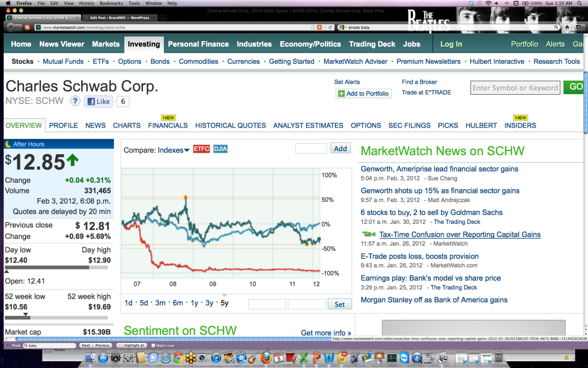

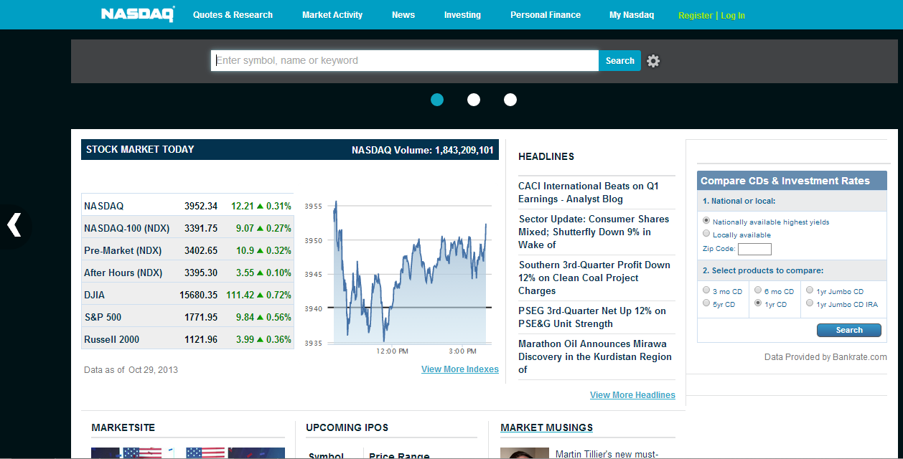[2]Nasdaq.com

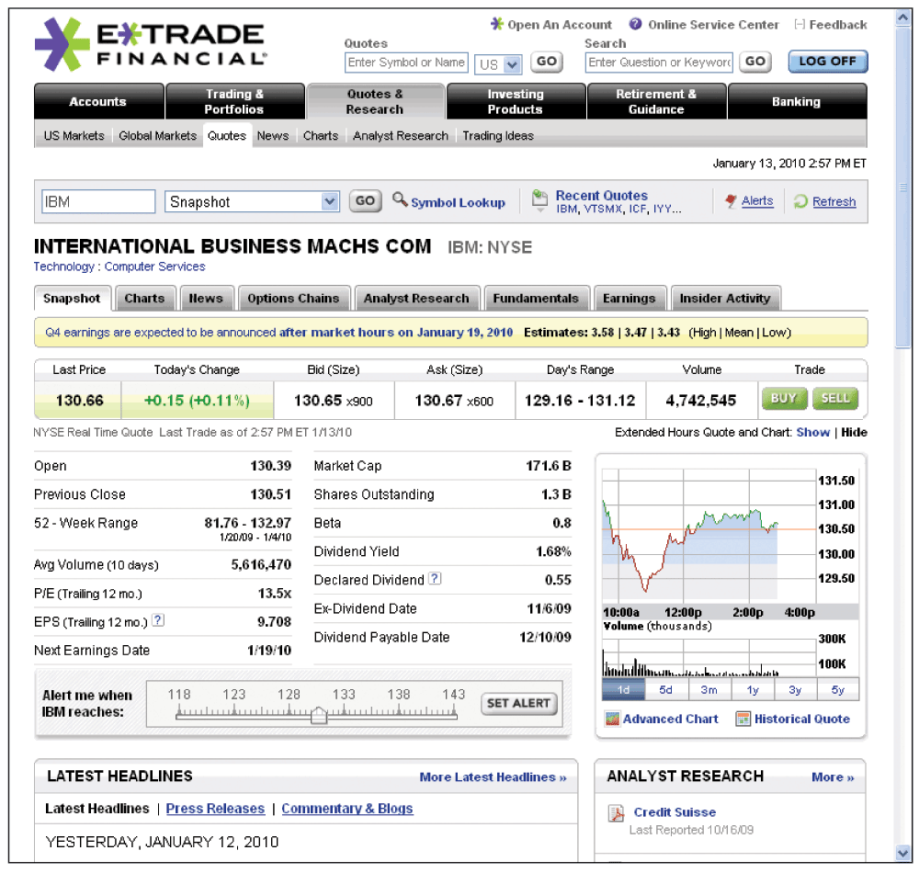[3]us.etrade.com

What seems to be a common impression of stock broker websites is that they need to hold a LOT of information, so much in fact, that interfaces gets clustered and the user is “overloaded” with information.

Elements to consider in these images;

* Navigation on image 1. Note how you close to the top can navigate between 9 or so tabs, and then there are sub categorical tabs, another eleven tabs. When “stocks” tab is selected, another navigation bar of yet another twelve tabs is presented. Now that’s a mouthful.
* Consider image 2 and 3. They both have done quite well on categorizing the elements of UI, but I still wish there were stronger dividers between the blocks of information.

**Mobile Apps**

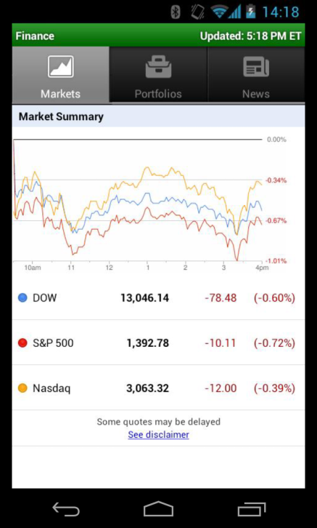[4]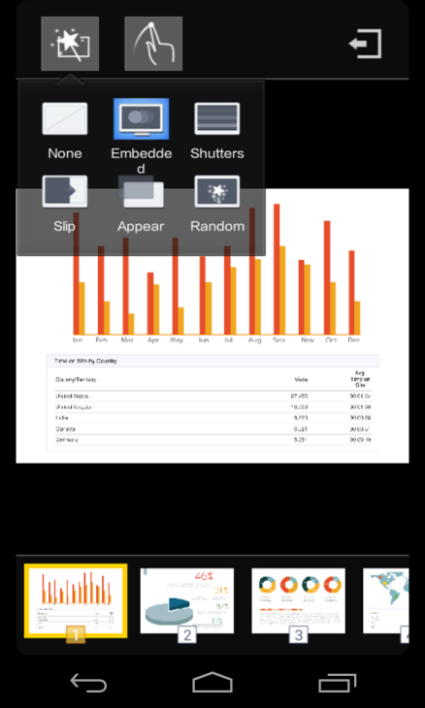[5]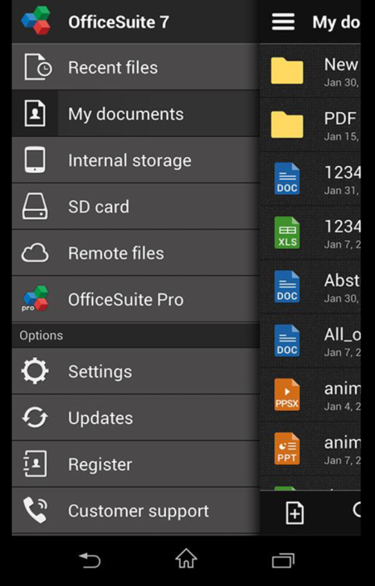[6]

On the mobile platform the information presented is far less than on websites, but is that a suitable tradeoff in our case? Would we want to compromise the quantity of information for the sake of maneuverability and design?

Important elements to consider from these images are as follows;

* Tabs on image 4, for quick and easy navigation between pages.
* Icons on image 6. Simple icons that clearly states the action through metaphors, a powerful tool.
* Drop down menu on image 5, the perfect use of both tabs and icons.
* Color coding of file types on image 6. We won’t be having file types as these in our system, but color coding is indeed a very powerful technique for a swift overview.

Now I believe some information must have been left out of Google Finance (the other two are not stock related) but that is indeed for the better of the system. Mobile applications are more commonly used for brief overlook rather than for thorough analysis anyway.

**Desktop Applications**

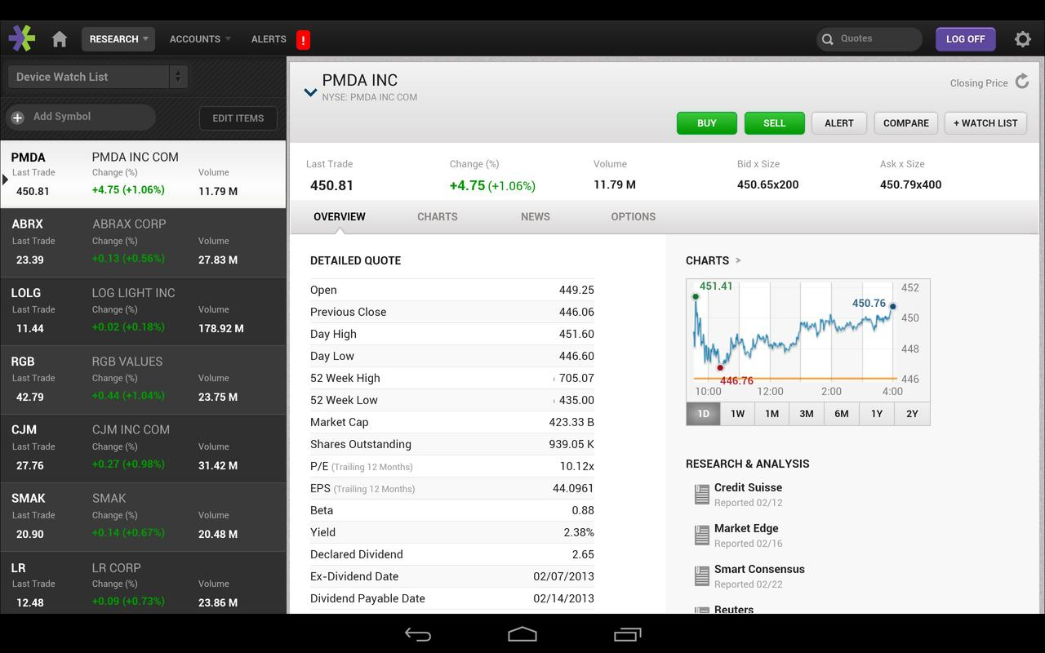[7]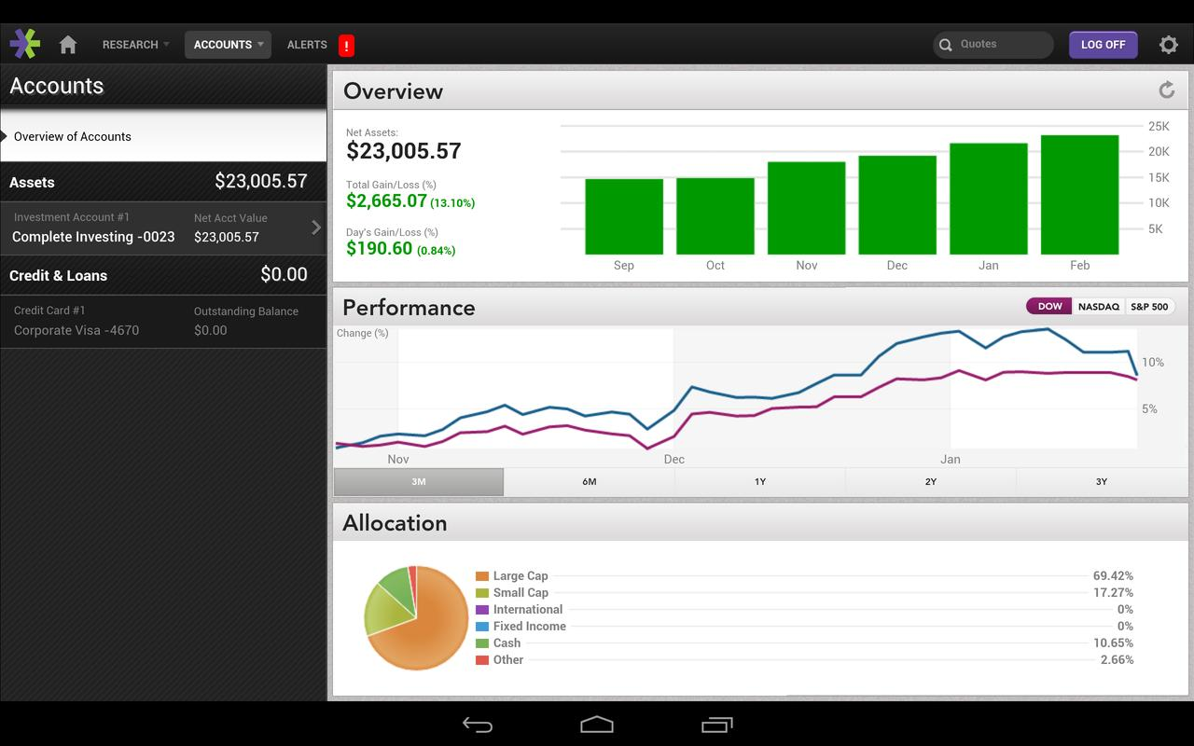[8]

I could not find any desktop applications that were not a complete UI disaster so I present these two images of the “E*Trade” application, which is actually a mobile app for tablets. Since it is designed for tablets, and thus has suitable dimensions, it works well for the sake of argument on desktop applications as well.

Elements to consider in these two images;

* The color coding of the different sections are outstanding. The colors are distinct and easy on your eyes. Also, color is used in perfect moderation. Lagom, a swede would say.
* Different blocks in the UI are distinctively separated by dividers and different colors.
* Navigation is handled through navigation bars and sections that are not part of the realized data.

# RESULTS

**Initial report conclusion**

It seems as though stock broker websites are generally focused on people who would accept some learning curve in using the software. They are in general not pretty, not easily navigated and the amount of data can be quite overwhelming. Mobile applications on the other hand seem simplified to the extent where they simply couldn't possibly contain all data necessary for a complete stock broker system. I think it is a fair conclusion to say that the E*Star application comes closer to achieving our ambitions than any other case presented in this research.

So what elements of UI do we want to bring into our design theme? How will these be brought into one consistent theme?

- Icons for one are one of the most powerful tools of UI. Icons made for this project will be used on all platforms, all to achieve consistency.

- Color coding of different blocks of information and indexes in lists and so on. A pallet will be created containing 4-5 colors, and these will be the only colors used in the entire system, regardless of platform.

- Navigation bars will be created with much consideration. For the mobile platform this is especially important, and so click tests will be performed to study efficiency of navigation tools.

E*star may serve as bit of an inspiration for our design standards, as they have done a really good job in bringing design and functionality together.

Below are the visual results of this report. The pallet picture stands as source for the color to be used in UI. This picture is located in the same folder as this report. Below it are the two fonts listed.

The font to be used in text body is: CENTURY GOTHIC.

The font to be used in headings is: CALIBRI BOLD. Text color is always white or black unless it is stock values as stated in the *pallet picture*.

**Changes**

The front end bit of the project was not initiated until the back end was completely finished and most of the UI concerns stressed in this report were agreed on. Thus, all developers knew roughly what their layout would look like. Some minor flaws were corrected and adjusted to match all platforms.

One of the major changes made to the desktop apps' design was the placement of all elements according to the UI specifications we have in our project and after consulting the UI Designer. Another adjustment was to make the application resizable dynamically. Changes to the colors where made at the very end. These where discussed with the UI Designer and applied accordingly.

**Feedback related changes**

Even though that was our goal already, we decided to stress consistency over platforms even further, and have all the features checked by the UI responsible of the group. This way, all elements of the design would first be developed based on the judgment of the developer, and then judged finally by the very same person on all platform.

**Fixed standards**

Colors used in the system:

1. #222222 UI Navigation, Dark Gray
2. #282828 UI Navigation 2, Gray
3. #ECEEEE UI List item
4. #FFFFFF UI List item 2
5. #E2E2E8 UI Background
6. #A92C28 UI misc., Red
7. #8EED5F UI misc., Green
8. #FFA500 UI misc., Orange
9. #f5f5f5 Text: Smoke White
10. # 444444 Text: Dark Gray
11. #3d3d3d Text: Darker Gray

Text Font: CENTURY GOTHIC

Header Font: **CALIBRI BOLD**

Application of colors shown below;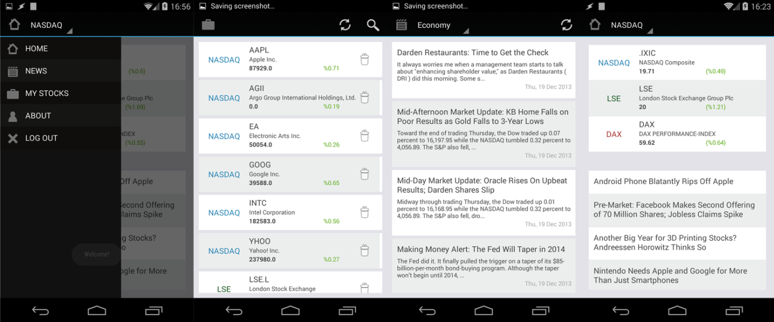

# ATTACHED: FEEDBACK #1, WILLIAM GRANLI

You should expect users to use at least 2 out of the 3 platforms. (Mobile/desktop/web). An important feature in UI: s is resemblance. User has done the stuff before and therefore can foresee what an element does (=affordance). Therefore I think you should focus a bit more on resemblance between the 3 UI: s.

You seem to value simplicity and minimalism a lot in the design, here are some points to consider improving:

* Progressive disclosure (Show only what is necessary for the moment)
* Constraints (Limit the actions possible to perform tasks)
  + Physical
    - Paths (Constrain movement to location/direction)
    - Barriers (Constrain movement to only appropriate areas of the interface)
  + Psychological
    - Conventions (Design systems that go well with the user’s habits)
    - Mapping (Relationship between controls and effects)
    - Symbols
* Memorability
  + Location
  + Logical grouping
  + Conventions
* Predictability (How easy it is to predict the results of an action)
* Visibility (Make the user aware of all functions)
* Proportions (Different sizes of text to represent hierarchy)

There are specific design processes for UI design, consider describing your way of working:

* User-centered design (Focused on user early on, done iteratively. Questionnaires etc.)
* Dynamic systems development model (Same as above but requirements are never set and are renewed through user contact all throughout)

If you want to perform more checklist based interviews/evaluations, consider this:

**Eason’s criteria**

* Task complexity
* Frequency of use
* Adaptability

**Andy Smith’s criteria**

* Application knowledge
* System knowledge
* IT literacy

# ATTACHED: FEEDBACK #2, MAGNUS HERNEGREN

“I think that the method the designer has used is a great one. I appreciate the way that the research has been conducted, which seems to mainly be about researching current options for stock information and then thinking about how the bad ones can be improved, and how the good ones can offer guidelines towards their own development. I think the choice to decide a common color scheme and font usage for all applications is wise and will contribute to creating a feeling of a united software suite rather than three totally different apps.”

1. Marketwatch.com
2. Nasdaq.com
3. Us.etrade.com
4. Google Finance
5. OfficeSuite 7
6. OfficeSuite 7
7. E*Trade
8. E*Trade